Press Release
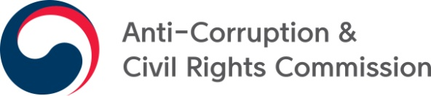 | ▪ January 31 (Tue), 2023 ▪ 4 pages (2 page of attachment)
 | ▪ ( Embargo) January 31 (Tue), 2023 2 p.m.
General Anti-Corruption Policy Div.
Director ☏ 82-44-200-7611
Deputy Director ☏ 82-44-200-7619
“Korea Hit a Record High, Ranking 31st in the 2022 Corruption Perceptions Index (CPI)”

- Korea ranked 31st among 180 countries in the 2022 CPI published by Transparency International, a rise for six years in a row -

- The Anti-Corruption and Civil Rights Commission (ACRC, Chairperson Jeon Hyun-Heui) announced that in the 2022 Corruption Perceptions Index (CPI) released on January 31 by the Transparency International (TI), Korea hit a record high, scoring 62 points on a maximum of 100 points and ranking 31st out of 180 countries and territories.

Korea’s raking and score increased by 1 notch and 1 point, respectively from those of 2021 and they have been on the rise for six consecutive years since the implementation of the Improper Solicitation and Graft Act in 2016.
*’17: 51st (54) →’18: 45th (57) →’19: 39th (59) →’20: 33rd (61) →’21: 32nd (62) →’22: 31st (63)

CPI published every year since 1995 by Transparency International based in Germany is a globally representative anti-corruption index that assesses each country’s perceived level of corruption in the public and political sector.
< Year of Introduction and Operation of Anti-Corruption Policies >
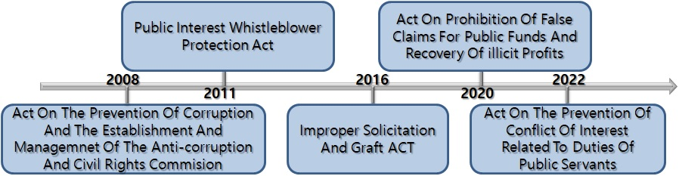

< Changes in Korea’s CPI scores and ranking >
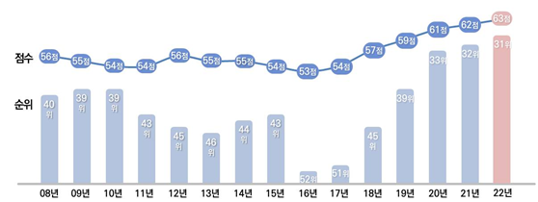
- This result may be attributable to the government’s strong will and efforts for law enforcement in accordance with laws and principles which has been constantly emphasized since the launch of the Yoon administration, the consistent pan-government anti-corruption reform movement promoted by various ministries including the ACRC, and the corruption prevention efforts pursued by the general public, civil society organizations, the media and academia, etc.
Specifically, the ACRC has played a leading role in improving the CPI through supplementing national anti-corruption policies including the Improper Solicitation and Graft Act (the Anti-Graft Act) for corruption prevention in the country. In particular, ACRC enhanced the integrity awareness in the public sector by completing the nation’s anti-corruption legal institution through the enactment and enforcement of the Anti-Graft Act and Act on the Prevention of Conflict of Interest Related to Duties of Public Servants.
This can be confirmed through the fact that the proportion of survey respondents who said “the Anti-Graft Act has had a positive effect on our society” stood at 91.2%.
* People’s Idea Box survey of 4,482 people was conducted from Nov. 7 to 18.
The Ministry of Justice and the Fair Trade Commission, etc. have exerted efforts to effectively identify and punish crimes of corruption. They have reinforced investigation infrastructure to crack down on economic crimes, including those in the field of finance, stocks, fair trade and tax, and strengthened sanctions against violators.
- These pan-governmental anti-corruption efforts have made fruitful results in the Bribery Risk Matrix (BRM) published last November and the 2021 Index of Public Integrity (IPI).
In the Bribery Risk Matrix (BRM) of TRACE International based in the US measuring the likelihood of encountering bribe demands when doing business in a given jurisdiction, Korea hit a record high in the global ranking, classified as the country group of ‘low risk’ in terms of bribery risk.
In addition, in the 2021 Index of Public Integrity released biennially by European Research Center for Anti-corruption and State-Building (ERCAS), Korea ranked 18th among 114 countries and 1st in the Asian region.
- ACRC Chairperson Jeon Hyun-Heui said, “Korea could hit a record high in the 2022 CPI global ranking thanks to the combination of consistent government-wide anti-corruption reforms and the active support from the general public for the fight against corruption,” adding that “the ACRC will continue to push for systematic anti-corruption policies without being complacent about the 2022 CPI result, in order to take a leap forward as a country with an advanced level of integrity that matches its global standing in the international community.”
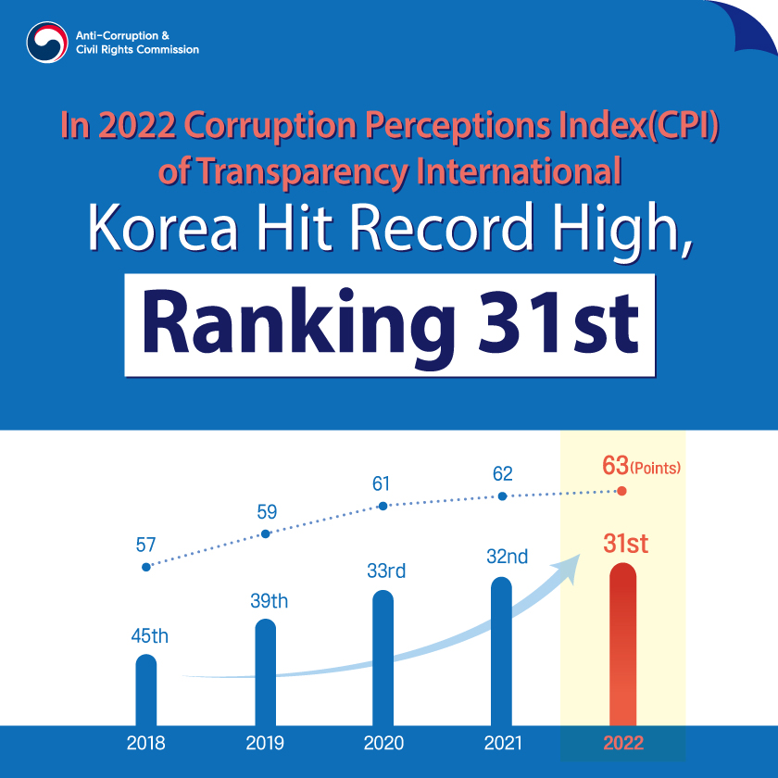
Reference |  | 2022 CPI Country Results

Global ranking | OECD ranking | Country | 2022 CPI
1 | 1 | Denmark | 90
2 | 2 | New Zealand | 87
2 | 2 | Finland | 87
4 | 4 | Norway | 84
5 | 5 | Sweden | 83
7 | 6 | Switzerland | 82
8 | 7 | Netherlands | 80
9 | 8 | Germany | 79
10 | 9 | Luxembourg | 77
10 | 9 | Ireland | 77
13 | 11 | Australia | 75
14 | 12 | Canada | 74
14 | 12 | Iceland | 74
14 | 12 | Estonia | 74
18 | 15 | United Kingdom | 73
18 | 15 | Belgium | 73
18 | 15 | Japan | 73
21 | 18 | France | 72
22 | 19 | Austria | 71
24 | 20 | United States of America | 69
27 | 21 | Chile | 67
31 | 22 | Korea, South | 63
31 | 22 | Israel | 63
33 | 24 | Portugal | 62
33 | 24 | Lithuania | 62
35 | 26 | Spain | 60
39 | 27 | Latvia | 59
41 | 28 | Slovenia | 56
41 | 28 | Italia | 56
41 | 28 | Czechia | 56
45 | 31 | Poland | 55
48 | 32 | Costa Rica | 54
49 | 33 | Slovakia | 53
51 | 34 | Greece | 52
77 | 35 | Hungary | 42
91 | 36 | Colombia | 39
101 | 37 | Turkey | 36
126 | 38 | Mexico | 31

